|  |  |  |  |  |
| --- | --- | --- | --- | --- |
| **Campaigns** | **Army XXX** | | **Army XXX** | |
| **Victory Points** | **Great Campaign Points** | **Victory Points** | **Great Campaign Points** |
| **Campaign xxx** |  |  |  |  |
| **Campaign xxx** |  |  |  |  |
| **Campaign xxx** |  |  |  |  |
| **Campaign xxx** |  |  |  |  |
| **Campaign xxx** |  |  |  |  |
|  |  |  |  |  |

**Great Campaign - XXX**

**The player with the most**

**Grand Campaign Points**

**wins the Grand Campaign.**

**If both players are tied,**

**the player with the most**

**Victory Points wins.**

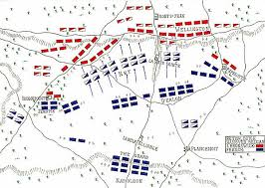

**Decisive Victory – 3 pts.**

Twice or more than the opponent´s VP

**Major Victory – 2 pts.** Greater than 3 Victory Point advantage pts.

**Minor Victory – 1 pt.**

Up to 3 Victory Point advantage

**Campaign Tie – 0 pt.**

Equal Points