Scenario Name - Date
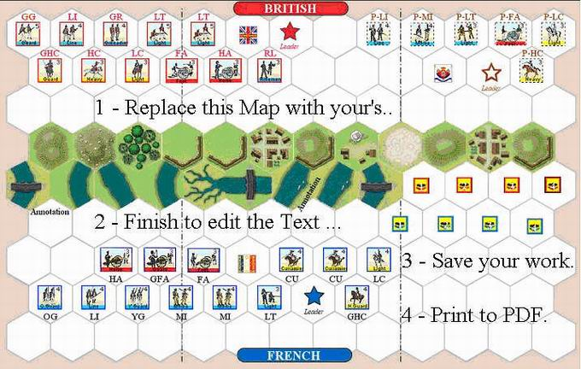

Historical Background
Type your text here.

The stage is set. The battle lines are drawn and you are in command. Can you change history?
Battle Notes
British Army
- Commander :
- x Command Cards
- Move First (delete if not..)

French Army
- Commander :
- x Command Cards
- Move First (delete if not..)

Victory
x Victory Banners

Special Rules
- None… or type here any special rules for your scenario.

